MedDoc

Problem Statement:

The IoT revolution will also have a great impact in the healthcare industry. Use technology to create smart healthcare solutions for people residing in urban centres. A unified healthcare system, with collecting and sharing of data along with analysis and research practices, is what will determine the future of urban healthcare

Main Objectives:

* To help the people in urban areas with their medical treatments and information.
* Let people know about their medication and level of the treatment.
* Let hospitals to enter the patients details in the database and make it work with an android application.
* People in urban areas can use the app and know about their medication and all the details.

Description

* We develop a database for people in urban areas to help in their medication.
* People can get used of this and know about their history of check ups and their medical file (X-Ray , Scan , etc,.).
* We are developing an android application with this database to access those details.
* People can easily access this app from anywhere to get details.

Flowchart:

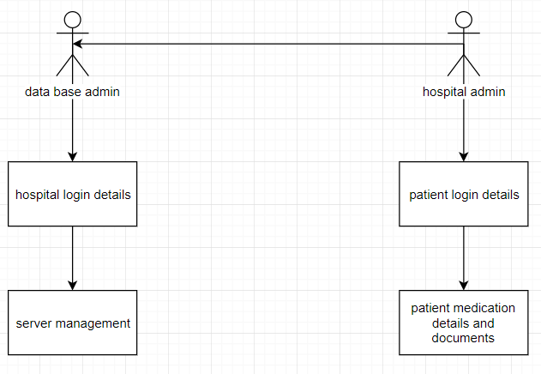

Snapshorts:

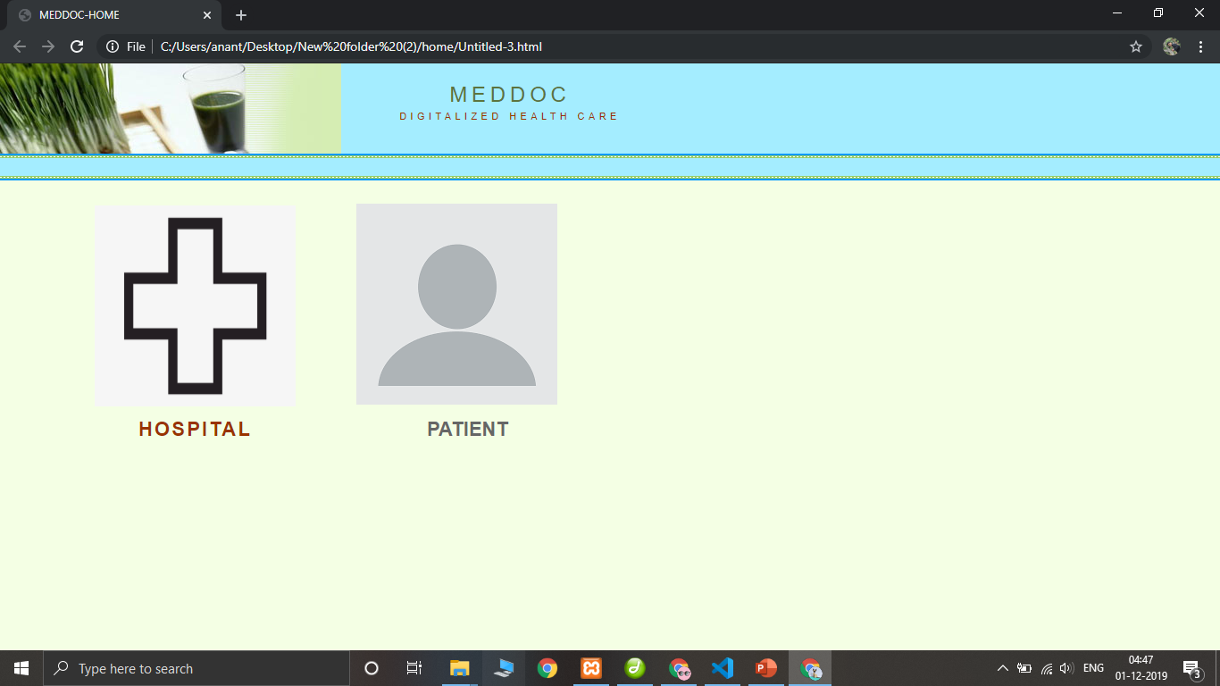

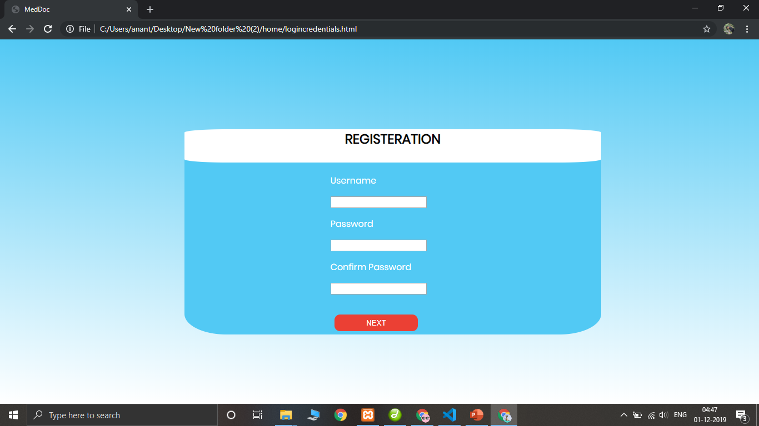

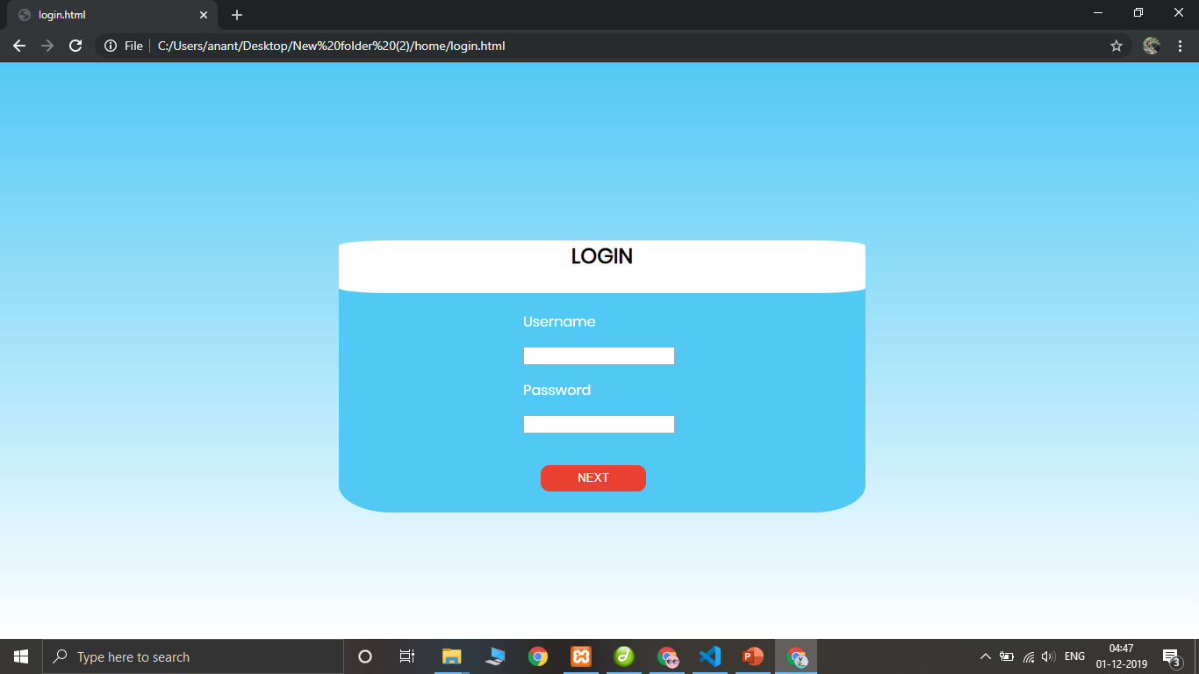

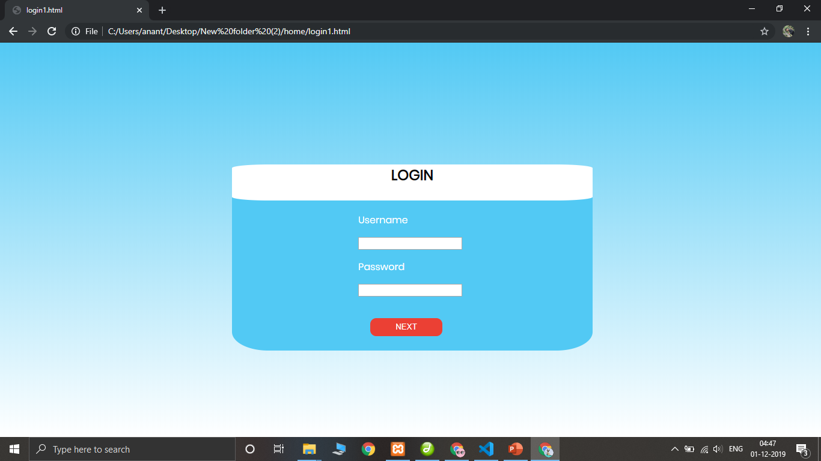

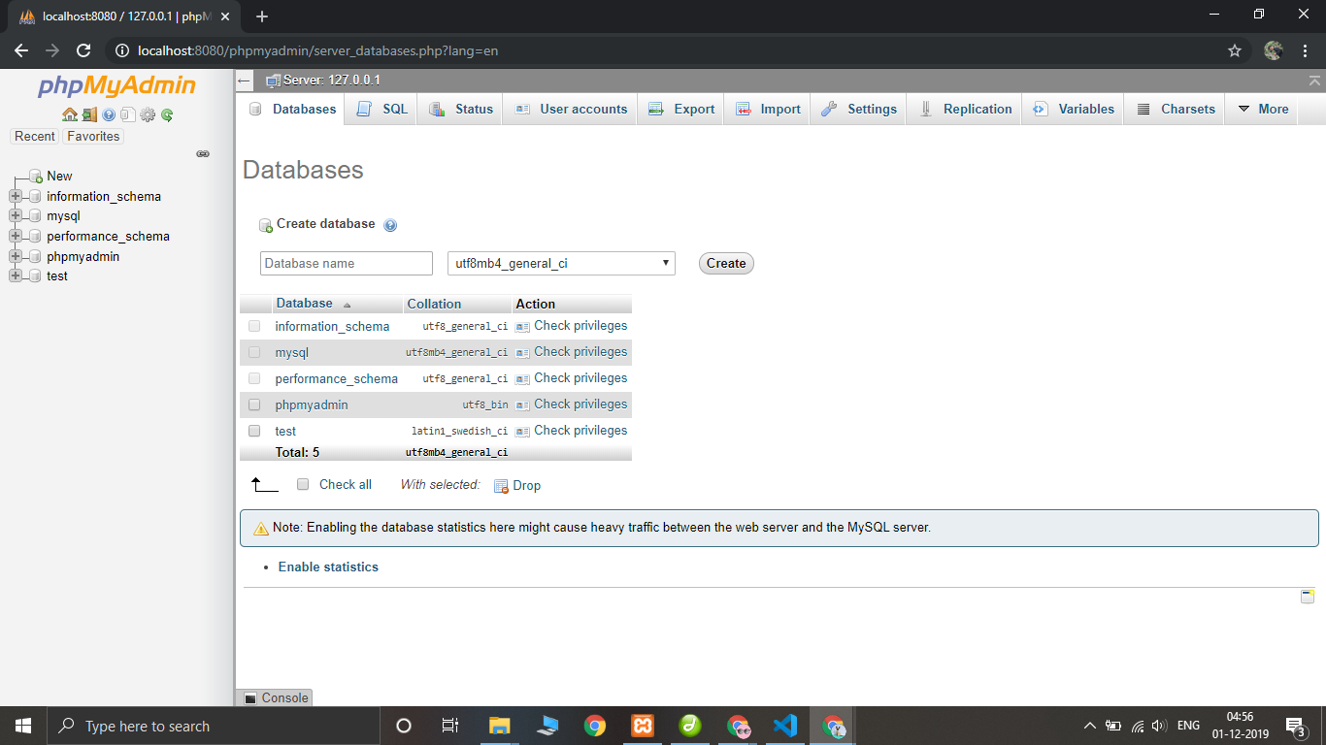

This is the Digitalized Medical repor which is used to get all the details of our health and we can use it at any place in the world.